# SIGN LANGUAGE DETECTION SYSTEM



**Submitted By:**

# Group 14

**Cranes Regd. No: CL2025010601916399 College Regd. No: 2201020228 Name: SHUBHJEET KHAN**

**Cranes Regd. No: CL2025010601902785 College Regd. No: 2201020234 Name: SUBHASHISH GHOSH**

**Cranes Regd. No: CL2025010601915995 College Regd. No: 2201020222 Name: RISHAV KUMAR**

**Cranes Regd. No: CL20250106019164100 College Regd. No: 2201020239 Name: GOURISHANKAR**

**MOHAPATRA**

**Department of Computer Science & Engineering**

**C.V. Raman Global University, Bhubaneswar, Odisha 752054**

**Table of Contents**

## Problem Specification 3

## Introduction 4

## Background 4

## Challenges 5

## Problem Statement 6

## Proposed Solution 7

## Description 7

## Flow Chart 8-9

## Algorithm 10

## Source Code 11-15

## Result & Analysis 16

## Explanation of Source Code 16-18

## Conclusion 19

## 

**PROBLEM SPECIFICATION**

**OBJECTIVE:** The development and implementation of the Sign Language Detection System (SLDS) are guided by clear and measurable goals. This system aims to assist individuals with hearing or speech impairments by enabling real-time recognition and translation of sign language into textual or audible formats. The core objective is to bridge the communication gap between sign language users and non-signers through a machine learning-based solution.

## Database Structure:

The dataset used for training and validating the Sign Language Detection model consists of the following structured components:

* **Images / Frames:** Captured hand gestures representing various alphabets or signs.
* **Labels:** Each image/frame is labeled with its corresponding alphabet or meaning (e.g., "A", "B", "Hello").
* **Metadata (optional):**

**frame_id:** Unique identifier for each frame.

**gesture_name:** Name/label of the sign represented.

**timestamp:** Time at which the frame was captured (for real-time systems).

## Constraints:

* The input images must clearly show hand gestures within a specific frame region.

## The lighting conditions and background should be uniform for optimal detection accuracy.

## The dataset should be well-balanced across all gesture classes to prevent bias.

## The model should have a minimum accuracy of 85% for practical use.

## System Functionalities:

## Real-time webcam integration for gesture capture.

## Pre-trained model for sign detection.

## Output display in the form of:

## Text on screen

## Optional voice output using Text-to-Speech

# INTRODUCTION

* The Sign Language Detection System using Data Science is an innovative solution designed to bridge the communication gap between the hearing-impaired community and the general population. In an era where inclusivity and accessibility are becoming fundamental, this system presents a practical and intelligent tool that enables seamless interaction using hand gestures interpreted through computer vision and deep learning techniques.
* By leveraging the power of machine learning frameworks such as **TensorFlow** or **Keras**, combined with **Convolutional Neural Networks (CNNs)** and **Long Short-Term Memory (LSTM)** architectures, the system accurately identifies and interprets sign language from image or video inputs. The real-time detection capability, coupled with a user-friendly interface, ensures that users can effortlessly translate sign language into text or voice, thereby enhancing communication and accessibility.
* In today’s tech-driven society, the need for accessible communication tools is critical. This Sign Language Detection System addresses this need by offering a modular, scalable, and highly adaptable design. The solution is structured to support additional gesture classes and languages in the future, making it a significant step toward inclusive communication in digital platforms.
* Recent years have witnessed significant developments in deep learning, gesture recognition, and image processing, laying the foundation for accurate and efficient sign language translation systems. These advancements have been made possible due to the availability of large labeled datasets, improved model architectures, and enhanced computational capabilities.
* By building on this foundation, the current project aims to implement a system that not only detects sign language accurately but also translates it in real-time, fostering better inclusion and communication for all.

# CHALLENGES

1. **Data Quality and Labeling:** Ensuring the dataset used for training is accurately labeled is critical. Mislabeling hand gestures can significantly reduce model performance and lead to incorrect predictions during real-time detection.
2. **Gesture Similarity:** Some signs are visually very similar and only differ in subtle hand movements or finger positions. Distinguishing between such gestures poses a major challenge for the detection algorithm.
3. **Lighting and Background Conditions:** The accuracy of gesture recognition can be severely affected by variations in lighting and cluttered backgrounds. Standardizing input conditions or implementing background segmentation is necessary.
4. **Real-Time Performance:** Achieving low-latency, real-time detection is technically demanding. Processing video frames quickly without compromising accuracy requires efficient model architecture and hardware acceleration.
5. **Hand Occlusion and Partial Gestures:** The model must be robust enough to handle cases where the hand is partially visible or occluded by objects, which is common in real-world scenarios.
6. **User Variability:** Different users may perform the same sign with slight personal variations in speed, angle, and gesture execution. The system must generalize well across different users and styles.
7. **Model Overfitting:** Overfitting to training data is a common problem in deep learning. Proper regularization, dropout, and data augmentation techniques must be applied to ensure the model performs well on unseen data.
8. **Dataset Imbalance:** An imbalanced dataset, where some signs are over-represented and others under-represented, can bias the model. Techniques like SMOTE, weighted loss functions, or balanced sampling are required.
9. **Scalability:** As new signs or languages are added, the model architecture and training pipeline must be flexible enough to accommodate them without needing complete retraining.
10. **User Interface Integration:** Designing a clean and intuitive user interface that displays recognized signs in text or speech form is essential for usability, especially for non-technical users.

# PROBLEM STATEMENT

* This project involves the development of an intelligent system that assists in the real-time detection and translation of sign language gestures into readable or audible formats. The system is particularly valuable for enhancing communication between the hearing-impaired community and non-signers in various social, educational, and professional settings.
* The creation of a robust Sign Language Detection System aims to address the existing communication barriers faced by the hearing and speech impaired. This system leverages deep learning and computer vision technologies to recognize hand gestures with high accuracy and translate them into human-interpretable output. By providing a scalable, accessible, and interactive solution, the system enhances inclusivity, ensures efficient gesture recognition in real-time, supports future enhancements (such as new sign languages or regional signs), and promotes broader adoption in educational, healthcare, and public service environments.

# DESCRIPTION

The Sign Language Detection System is a comprehensive machine learning-based solution designed to automate and facilitate real-time gesture recognition for translating sign language into human-readable text or synthesized speech. This system acts as a central platform that integrates computer vision, deep learning, and natural language processing to enhance communication accessibility for individuals with hearing or speech impairments.

1. **Dataset Preparation:** The system begins with the preparation and preprocessing of a gesture dataset, consisting of labeled images or video frames representing various signs from a standard sign language such as ASL (American Sign Language) or ISL (Indian Sign Language). Data augmentation techniques are applied to improve generalization.
2. **Model Design – CNN Architecture:** A Convolutional Neural Network (CNN) is designed to extract spatial features from gesture images or video frames. This model is responsible for learning unique patterns and features associated with each sign.
3. **Model Design – LSTM Integration (Optional):** For continuous sign recognition or video-based input, a Long Short-Term Memory (LSTM) layer may be used to capture temporal dependencies between frames, allowing the system to understand gesture sequences as meaningful phrases.
4. **Training and Validation:** The CNN (and LSTM, if used) model is trained using the preprocessed dataset. During this phase, hyperparameters such as learning rate, batch size, and epochs are tuned to optimize performance and accuracy.
5. **Real-Time Detection Module:** A real-time recognition module is implemented using a live camera feed or video input. This module continuously captures hand gestures and predicts the corresponding sign using the trained model.
6. **Text & Speech Output:** The recognized sign is translated into text, which is displayed on the interface. Optionally, the output text is also converted into speech using a Text-to-Speech (TTS) engine, allowing auditory output of the recognized signs.
7. **User Interface:** A simple and intuitive GUI is developed to interact with the system. Users can initiate sign detection, view the translated text, and listen to the voice output in real time.
8. **System Output and Logs:** The system maintains logs of recognized gestures for analysis and improvement. It may also include performance metrics and confusion matrices to monitor model behavior.
9. **Preprocessing Pipeline:** Before feeding the input to the model, frames are preprocessed using several computer vision techniques such as grayscale conversion, Gaussian blur, thresholding, and contour detection. These steps help in isolating the hand region and removing background noise for better feature extraction.
10. **Hand Segmentation and ROI Extraction:** A region of interest (ROI) is defined dynamically or statically to capture the hand gesture from the video feed. Techniques like skin color filtering or MediaPipe hand tracking are used for more accurate segmentation.
11. **Gesture Prediction and Label Mapping:** The trained model outputs a class prediction (e.g., A–Z for alphabets or custom labels for words). These class IDs are mapped to actual gesture meanings using a label dictionary, which is displayed to the user.
12. **Multi-Gesture and Sentence Formation (Optional Advanced Feature):** The system can optionally detect a sequence of signs and concatenate them to form words or sentences. Buffering and debouncing logic are implemented to distinguish between separate gestures in a live stream.

# FLOWCHART

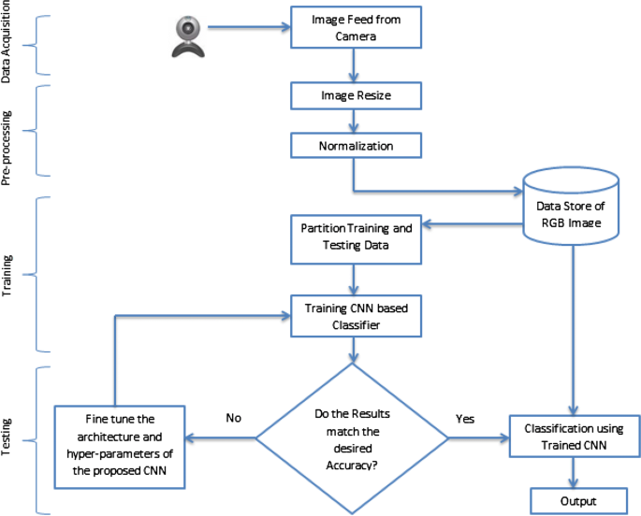

**ALGORITHM**

1. Start

User Initiates the Detection Process:  
a. Input user details (name, purpose for detection, preferred language model).  
b. Specify detection preferences (e.g., American Sign Language (ASL), Indian Sign Language (ISL), etc.).

2. Load and Initialize the Detection Model:  
a. Load the pre-trained sign language detection model into the system.  
b. If the model loads successfully:  
i. Confirm model initialization.  
ii. Display a message that the system is ready for detection.

3. User Provides Sign Input:  
a. User performs sign language gestures in front of the camera.  
b. System captures live video frames for processing.

4. Detect and Interpret Signs:  
a. System processes each captured frame.  
b. Apply pre-processing techniques (resizing, normalization) on input frames.  
c. Use the model to predict the gesture.

5. Display Detection Results:  
a. Check if a valid sign is detected.  
b. If a sign is recognized:  
i. Display the detected sign and its corresponding meaning on the screen.  
ii. Store the detection results temporarily.

6. User Confirmation (Optional):  
a. User can confirm if the detected sign is correct.  
b. If correction is needed, allow manual correction or retrain the model with new samples.

7. Save Detection History:  
a. Save the session’s detection data in a database or file.  
b. Record important details like timestamp, recognized signs, and corrections if any.

8. End

# SOURCE CODE:

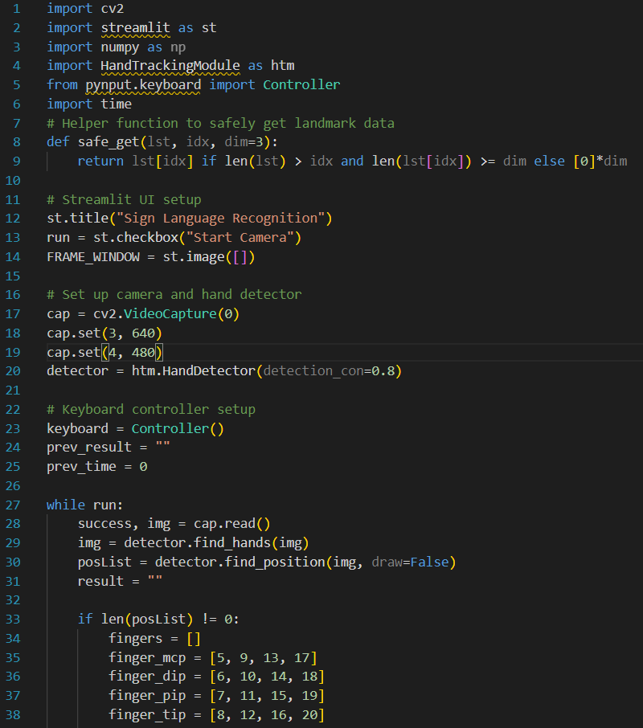

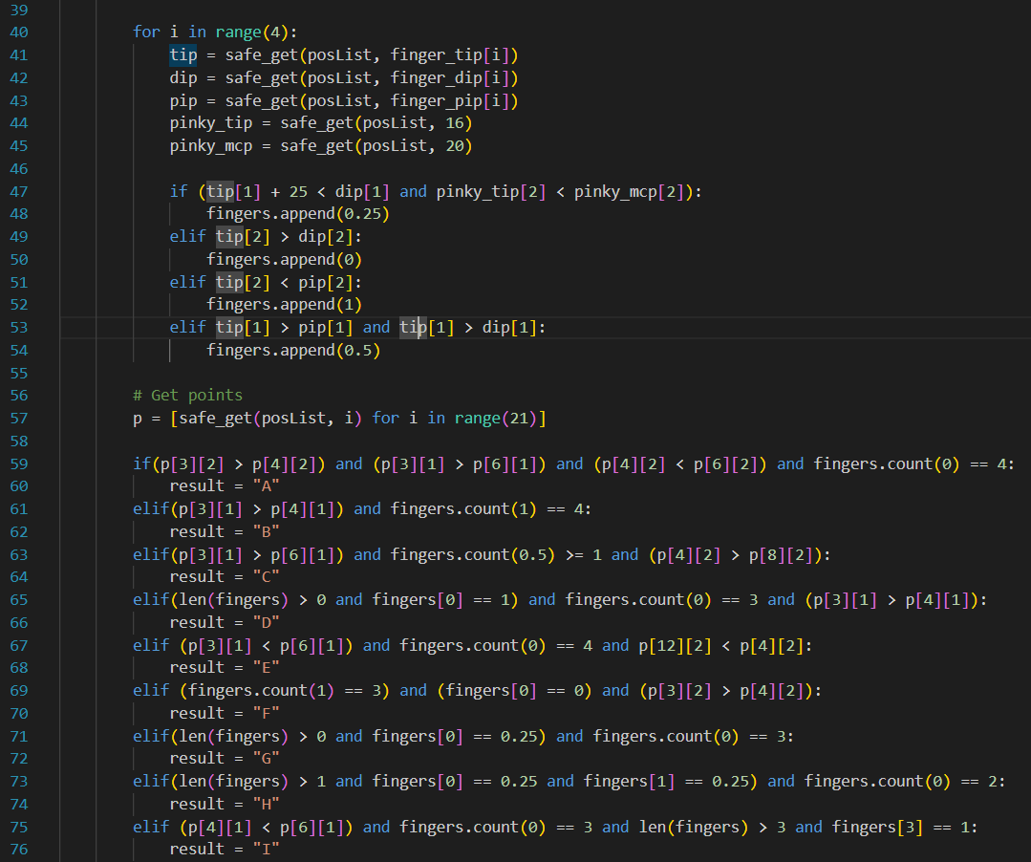

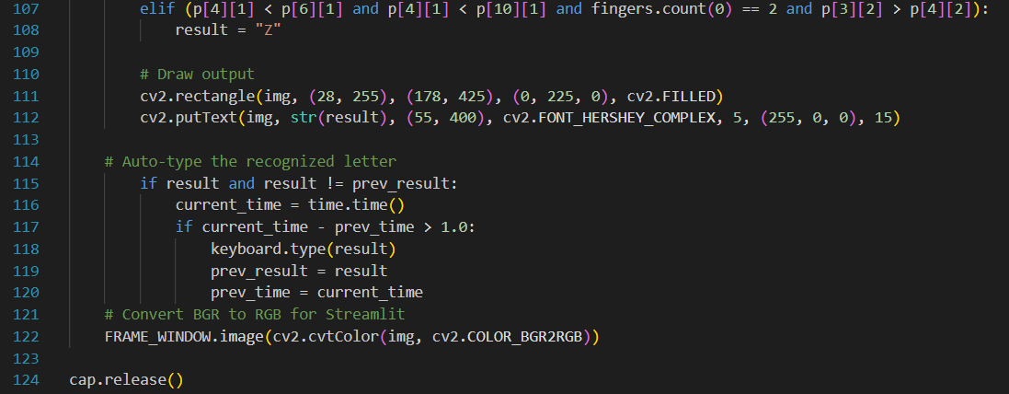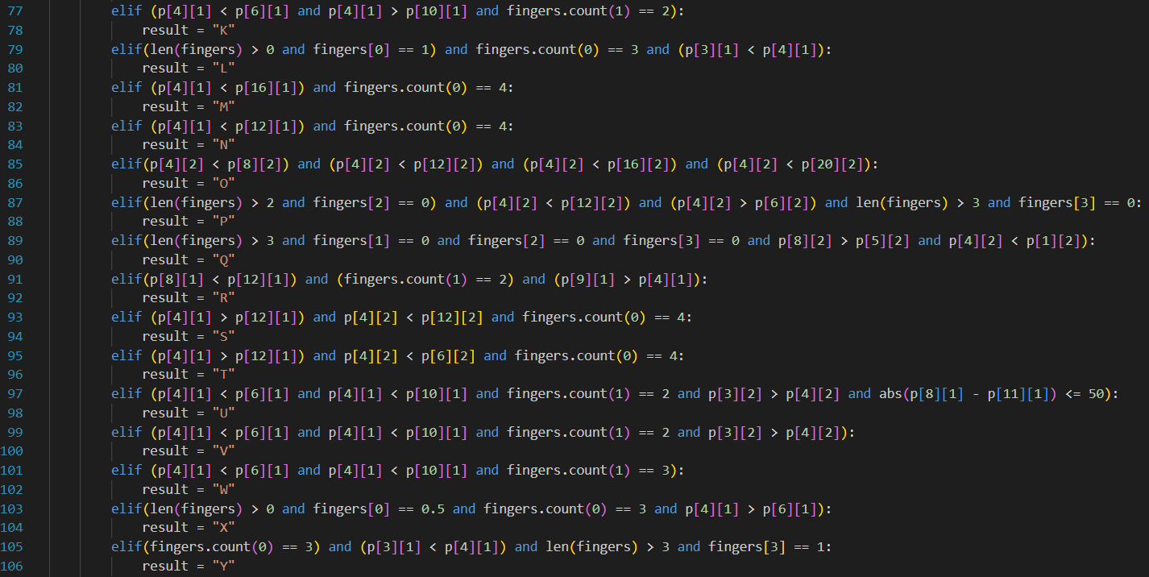

**ANALYSIS**

# Sign language detection involves interpreting hand gestures and movements to recognize letters, words, or phrases from sign language alphabets or vocabularies. This technology enables communication for people who are deaf or hard of hearing by translating manual signs into text or speech in real time.

# Key Aspects of Sign Language Detection in Implementation:

# Hand Landmark Detection:

# Detecting and tracking hand joints and finger positions with a hand tracking module, which provides keypoints for finger segments. These landmarks form the fundamental data for gesture interpretation.

# Finger State Analysis:

# The system analyzes finger bending and extension by comparing landmark coordinates. This step classifies each finger’s position (open, closed, half-open), crucial for distinguishing between similar gestures.

# Gesture Recognition Logic:

# A series of rule-based conditional statements map specific configurations of fingers and hand landmarks to ASL alphabet letters. This logical mapping simplifies recognizing static hand poses.

# Real-Time Processing:

# The program processes frames from a live webcam feed, allowing immediate detection and visual feedback. This real-time capability is essential for natural interaction and practical use.

# Automated Text Output:

# Recognized letters are typed automatically into the system using keyboard control, enabling hands-free transcription of sign language into digital text.

# User Interface Integration:

# Streamlit provides a user-friendly interface to display the video feed with overlayed detection results and a control to start/stop recognition, making the technology accessible through a browser.

# CONCLUSION

In conclusion, the development and implementation of a Sign Language Detection system represent a vital advancement towards bridging communication gaps and enhancing accessibility for the deaf and hard-of-hearing community. By thoroughly analyzing the limitations of manual interpretation and the need for real-time, automated translation, this system aims to transform the way sign language is recognized and utilized in everyday interactions.

The challenges identified, including the complexity of accurately detecting hand gestures, variability in user movements, and the necessity for prompt feedback, highlight the importance of a robust and intelligent technological solution. The project’s objectives focus on delivering precise, real-time recognition, user-friendly interaction, and seamless integration with existing digital platforms.

The outlined functional requirements encompass accurate hand landmark detection, effective gesture classification, and immediate output in textual form, addressing the core needs of both users and stakeholders. Acknowledging constraints such as computational resources, model accuracy, and environmental factors guides realistic development and deployment strategies.

Key deliverables such as the gesture recognition algorithm, integrated user interface, and comprehensive documentation mark critical milestones that ensure the system’s usability, maintainability, and scalability. These components collectively contribute to the successful realization of the project goals.

Ultimately, the Sign Language Detection system is more than just a technical implementation; it is a transformative tool designed to foster inclusivity, enhance communication, and empower users in various settings. By addressing the inherent challenges and fulfilling its objectives, this system stands poised to make a meaningful impact within the realm of assistive technologies and beyond.